**2. About the Park**

TITLE & LOGO

**BUY TICKETS (3)**

**NAVIGATION BAR**

MAIN PAGE (1)

ABOUT PARK/RIDES (2)

References on the pages are marked in the parentheses:

1. Main page, special offers
2. Park and scheme, rides, services description, safety
3. Tickets variants, shop, special offers

Services on the park’s territory, with photo

The main rides/attractions information.

Category

Ride title

Ride description with photo

Information how to get to the park.

Information about safety on the territory and on the objects.

About the park section:

Brief park story

The map of the park

Concise opening times information

FOOTER WITH CONTACTS, ADDRESS, REFERENCE TO SAFETY INFORMATION (2)

Version 2 (part 1)

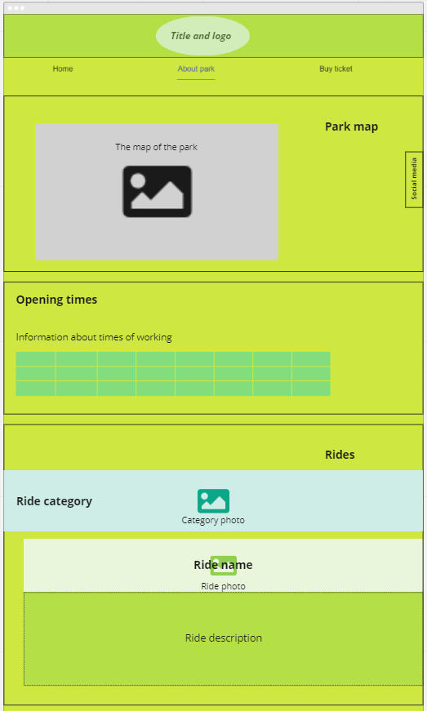

Version 2 (part 2)

